**Solar net meters data Report**

The solar net metering system allows consumers to generate electricity using solar panels and feed surplus energy back to the grid. This report analyzes Southern part of Telangana net metering data to assess regional performance and distribution.

1. **Data Description:**

The dataset consists **records** with the following key columns:

* **Location Information:**
  + circle, division, subdivision, section, area
* **Category Information:**
  + catcode and catdesc (e.g., Domestic, Non-Domestic)
* **Services Data:**
  + totservices (total services), billdservices (billed services)
* **Energy Metrics:**
  + units (energy units consumed/generated)
  + load (in kW; converted from HP for categories 3, 4, and 5)

1. **Analysis & Results:**
   1. **Total Units Consumed by Circle:**

This visualization highlights which circles have the highest (**Habsiguda**) and lowest (**Wanaparthy**) net metering activity, allowing for easy comparison across regions.

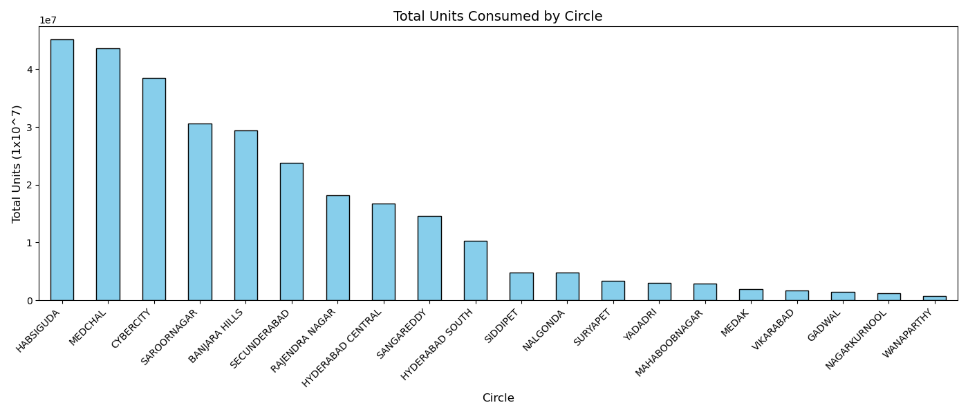

* 1. **Units per Service (Density):**

This helps identify regions with more efficient or concentrated solar usage. High values may indicate better adoption or larger installations per connection.

**Wanaparthy** has the **highest units per service**, indicating highly efficient or concentrated solar usage per connection.

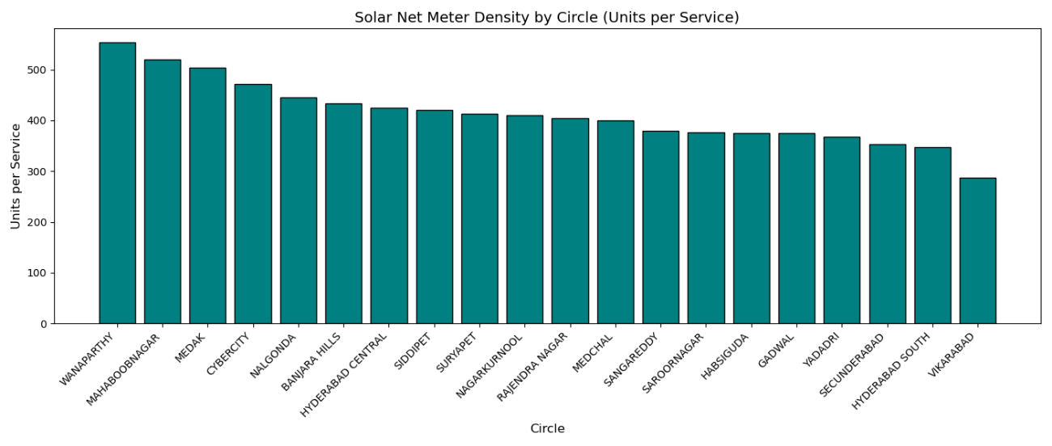**Warangal** shows the **lowest units per service**, suggesting either smaller-scale installations per connection or lower solar adoption in that circle.

**#** From the data on unit consumption per circle and units per service, we observe that while **Habsiguda** has the highest total energy consumption, **Wanaparthy** leads in terms of **units consumed per service**. This suggests that although Wanaparthy consumes less total energy overall, each individual service there tends to use more energy on average.

* 1. **Average solar net meter usage** **per Circle:**

The average solar net meter usage per circle provides insight into how effectively solar energy is being utilized across different regions. By calculating this within each circle, we can identify areas with higher solar penetration or more efficient usage patterns. Notably, some circles with lower total consumption still exhibit high average usage per service, indicating focused adoption or larger-scale individual installations. This metric helps highlight regions where solar net metering is having a stronger impact at the consumer level.

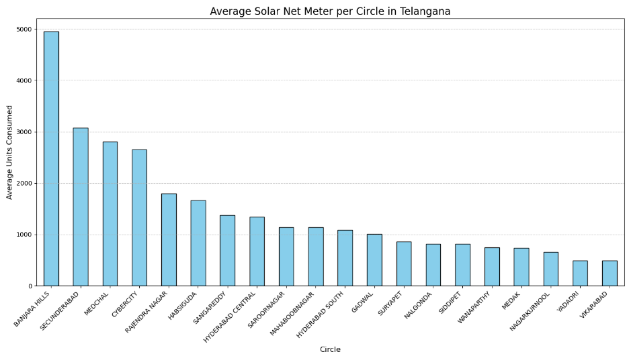

* 1. **Monthly Trend on Unit Consumption (Top 5 Circles + Others):**

The monthly trend of unit consumption, focusing on the top 5 circles and the average of all remaining circles, provides a clearer picture of where solar energy usage is most concentrated. Tracking these trends helps reveal which regions are showing consistent growth in adoption and which ones are more variable. Some top-performing circles demonstrate a steady increase in consumption, indicating rising awareness, improved infrastructure, or stronger policy support. Meanwhile, the average trend of other circles helps highlight the general pace of adoption across the rest of the region. This comparison supports better forecasting, resource allocation, and targeted investment in areas with untapped potential.

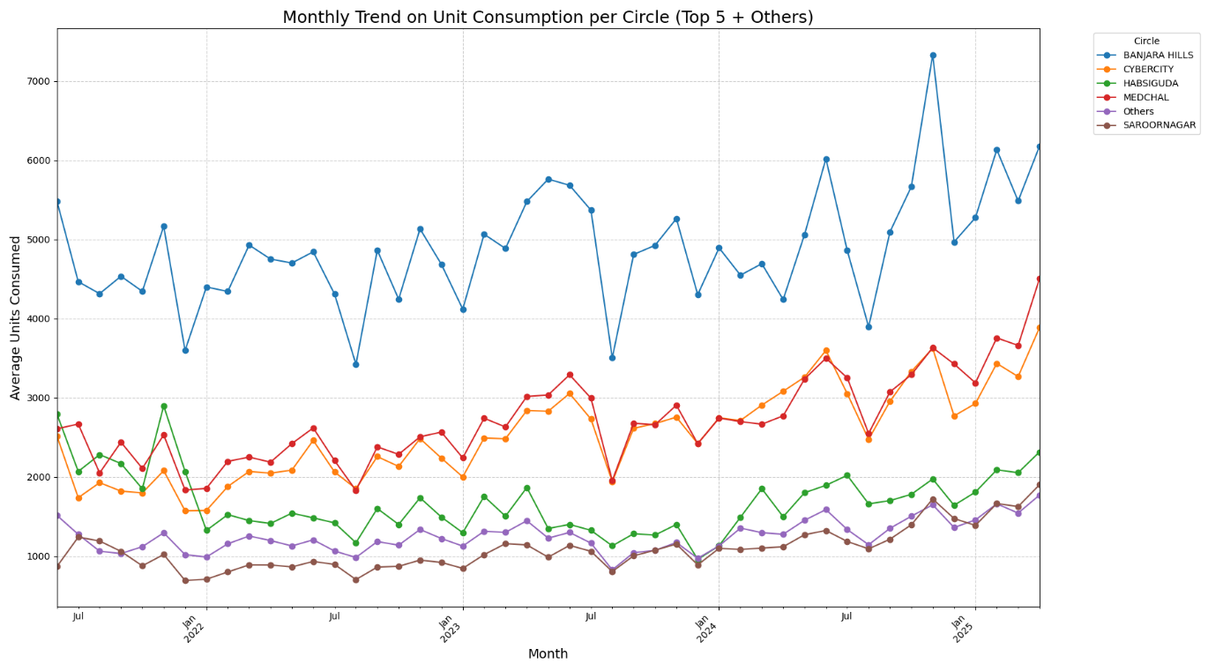

* 1. **Monthly Average Load (Top 5 Circles + Others):**

The analysis of monthly average load, focusing on the top 5 circles and the overall average of the remaining circles, offers a clear view of where the highest energy demands are being met. Among the top regions, **Banjara Hills** consistently records a significantly higher average load, suggesting a concentration of large-scale solar installations or consumers with higher power requirements—possibly due to commercial or high-usage residential setups. Comparing these leading circles to the average load of other regions helps identify disparities in infrastructure development and solar energy utilization. This distinction is valuable for prioritizing areas that may benefit from infrastructure upgrades or targeted support to enhance solar capacity.

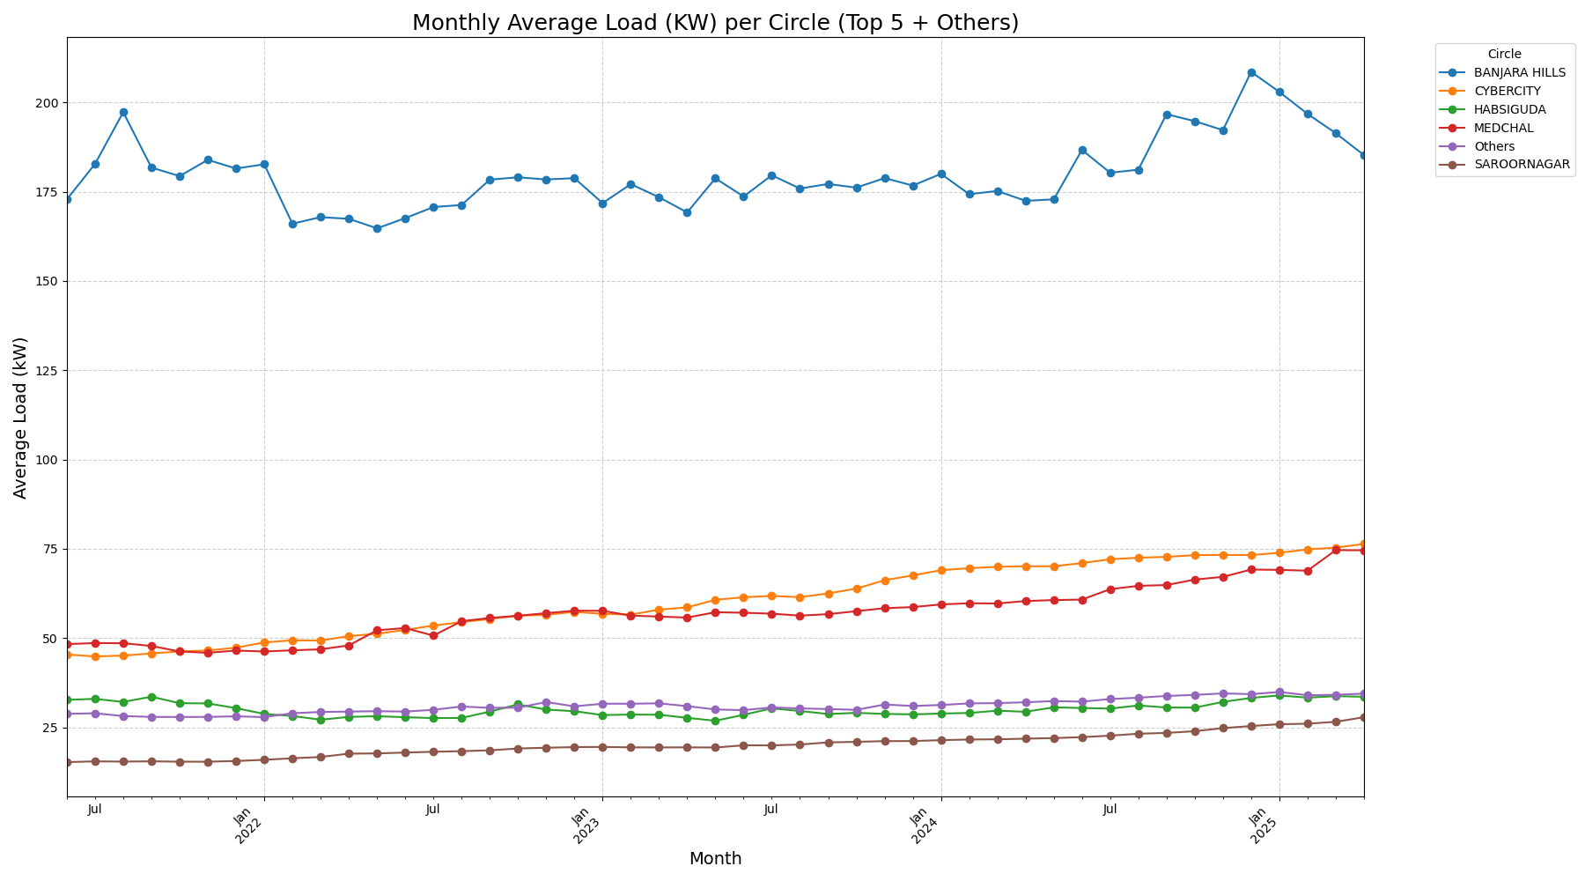

# 3 How This Data Can Be Used:

* **Policy Planning**: Identify high- and low-performing regions to develop targeted policies that encourage solar adoption where it's lagging.
* **Infrastructure Development**: Support planning for grid upgrades or additional solar infrastructure in areas with high load or rapid growth in usage like Banjara Hills.
* **Subsidy and Incentive Allocation**: Direct government subsidies and incentives toward circles with low solar penetration but high potential based on average service usage.
* **Forecasting and Demand Management**: Use monthly trends to predict future demand, helping utilities manage load and energy supply more efficiently.
* **Performance Benchmarking**: Compare circles to establish benchmarks for efficient solar net meter usage and set realistic targets for others to follow.
* **Outreach and Awareness Campaigns**: Focus awareness programs in circles where units per service are low, indicating under-utilization of solar net metering.
* **Energy Equity Analysis**: Evaluate how equitably solar energy benefits are being distributed among urban and rural circles, guiding inclusive energy access efforts.

# 4 Conclusion:

* The analysis reveals significant regional variation in solar net meter performance across southern Telangana, highlighting differences in energy consumption, service density, and load distribution.
* **Habsiguda** stands out for having the highest total energy consumption, indicating extensive adoption or larger installations, while **Wanaparthy**, despite lower total units, shows the highest **units per service**, suggesting more intensive usage per connection.
* **Banjara Hills** consistently shows a higher average load, likely due to the presence of commercial establishments or high-demand residential areas, pointing to a need for targeted infrastructure support.
* The **monthly trends** in unit consumption across circles suggest steady growth in some areas and seasonal or policy-related fluctuations in others, underscoring the importance of continuous monitoring.
* The **average solar net meter usage per circle** offers a valuable metric for understanding efficiency and potential. Regions with high average usage but low total consumption may benefit from broader outreach and infrastructure expansion.
* Overall, the data-driven insights from this analysis can support more informed decisions around solar policy, investment priorities, and regional planning for sustainable energy growth.

# Links:

**https://github.com/gt-rio/Solar-Net-Meter-Data.git**